Faculty of Science & Engineering

Research Ethics Committee
- Expedited Ethics Form -

Thank you for engaging with the Faculty of Science & Engineering Research Ethics application process. Please read the following in full before proceeding with your application:

Please note that all Health Research oversight on behalf of the University of Limerick is undertaken by the Health Research Oversight Committee (HROC). The HROC First Contact Questionnaire can be found here. The HROC reports to the University Research Committee (URC), chaired by the VPR. If you are conducting health research, you must engage with the HROC prior to or in parallel with submitting this application. For more information, please see the UL Health Research Policy.
If this study involves patients or staff from a clinical, hospital, or GP setting then you MUST apply to the relevant Ethics Committee where the patients or staff are based (for example, if you are working with patients in UHL, you will need HSE ethics approval).

If this is a new application, please proceed to Section B
If this is an existing application which requires clarification, please proceed to Section A

This form must be typed.

Supervisor/Principal Investigator Declaration

I, the undersigned, hereby declare that this submission is entirely the work of my own and my research team (i.e. students, collaborating staff, etc.). I understand the ethical implications of my research and this work meets, to the best of my knowledge, the requirements of the Faculty of Science & Engineering Research Ethics Committee. I confirm that I have reviewed this application and agree to its submission for review.

Supervisor/ Principal Investigator*: | Dr. Roisin Lyons | Date:  26-11-2025

SECTION A
Please ensure Track Changes is enabled (in the Review tab above) before addressing the below clarifications
Clarifications:
08) 2026_02_08_S&E
Beyond Recognition: | Roisin Lyons | Oluwajomiloju Olajitan

Referred

- Section 5f: Please ensure your inclusion/exclusion criteria are appropriate for your study. For example, ensure you are recruiting healthy adults who are capable of giving informed consent, as mentioned in 5h
- Section 5i: Please specify the "secure environment".
- Section 5l: Please specify that OneDrive will be used to store the data.
- Section 5o: This section should be signed by the PI, not the researcher.
- Study links: Please provide links for your online information sheet, gated consent form, survey and CAPTCHA challenge
- Info sheet: Please remove the bullet point related to participants being audio/video recorded.
- ICF: Please do not presign the consent form.

Clarifications (26/02/26):
Please complete the responses section below, responding to each of the clarifications above, signposting to where in the text changes have been made.

Clarifications (16/03/26):
1. Please confirm (with proof), that no personal data is being recorded or held by Vercel or Render. If they are being used to store and/or process personal data, please consult UL Cloud Governance for further guidance.

Responses:
Please use this section to address all current and future clarifications.
Application No.:  2026_02_08_S&E |  | Application title:  Beyond Recognition
No. | Supervisor response |  | Reviewer 1 comments | Reviewer 2 comments
1 | Section 5f updated to include explicit inclusion criteria (adults aged 18+ capable of giving informed consent with access to a web browser) and exclusion criteria (anyone under 18). See tracked changes in Section 5f.
2 | Section 5i updated to specify that the frontend is hosted on Vercel and the backend on Render, both served over HTTPS. See tracked changes in Section 5i.
3 | Section 5l updated to explicitly state that UL's OneDrive will be used for data storage after project completion. See tracked changes in Section 5l.
4 | Section 5o signature updated to the PI (Dr. Roisin Lyons) instead of the researcher. See tracked changes in Section 5o.
5 | All study materials (information sheet, gated consent form, CAPTCHA challenges, and post-task questionnaire) are integrated into a single application flow at https://fyp-mu-nine.vercel.app/.
6 | Audio/video recording bullet point removed from the consent form as the study does not involve recording. See tracked changes in the Ethical Consent Form.
7 | Pre-filled dates and investigator signature removed from the consent form. See tracked changes in the Ethical Consent Form.
8 | No personal data is recorded or held by Vercel or Render.  Vercel (frontend): Vercel serves only static frontend files to participants' browsers. No study data passes through or is stored on Vercel. Web Analytics is not enabled (Screenshot A) and no database or storage is connected (Screenshot B).  Render (backend): The database stores only anonymised interaction data: challenge parameters, timestamps, success/failure outcomes, device class, and trajectory coordinates. No names, email addresses, IP addresses, cookies, or any identifying information is collected. Session identifiers are randomly generated UUIDs with no link to user identity. Environment variables confirm no PII-related configuration (Screenshot C).  Both platforms are GDPR-compliant and certified under the EU-US Data Privacy Framework.  Evidence: A.Vercel Analytics: not enabled (see attached), B.Vercel Storage: no database connected (see attached), C.Render Environment Variables: configuration secrets only, no PII (see attached), D.Vercel Security & Compliance: https://vercel.com/docs/security/compliance, E.Render Security: https://render.com/security , F. Render DPA: https://render.com/dpa  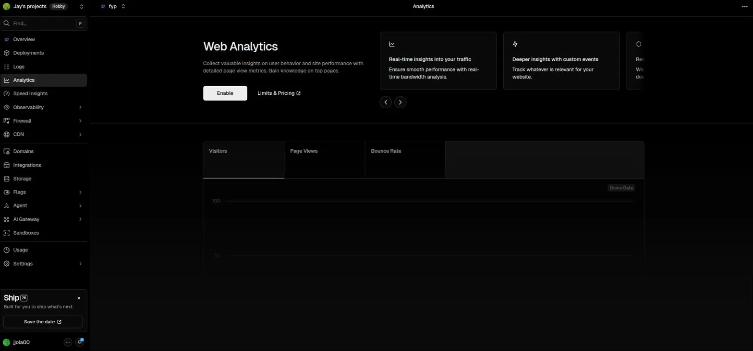  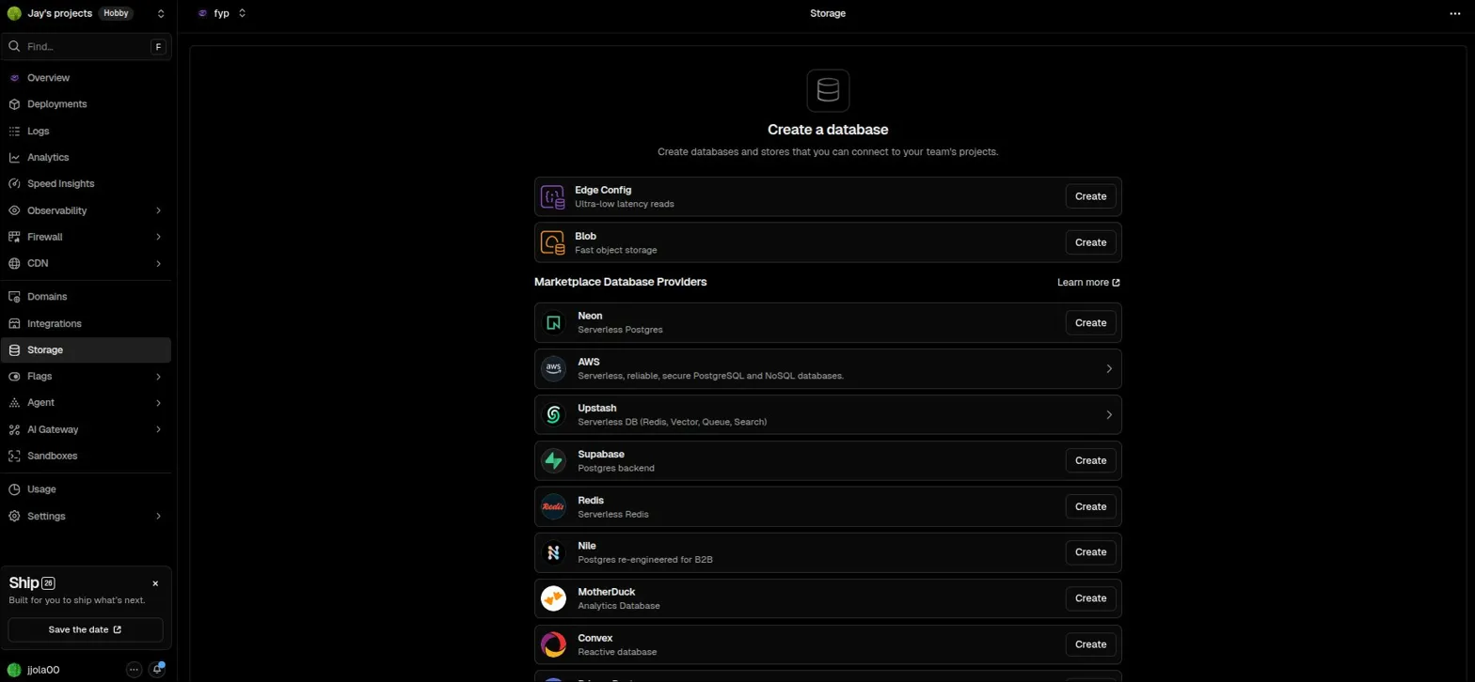  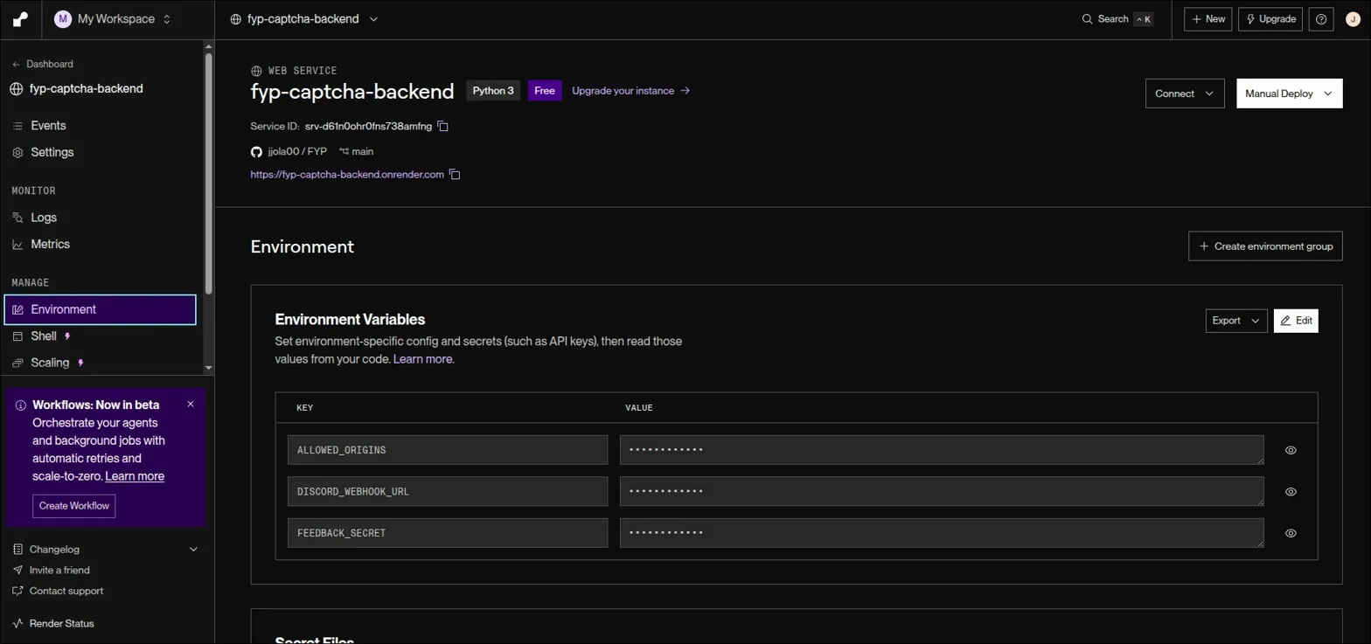

SECTION B
Click the arrowheads ► below to expand each section
Remove all comments before submitting to Megan.Howell@ul.ie
Blue shade: SUPERVISOR must complete Orange shade: APPLICANT must complete

Supervisor and Applicant Details

Supervisor name (i.e. Principal Investigator): | Dr. Roisin Lyons
Supervisor email: | Roisin.Lyons@ul.ie
Applicant name: | Oluwajomiloju Olajitan
ID number (if applicable): | 23373326
Email address (UL only): | 23373326@studentmail.ul.ie
FYP, MSc, PhD Dissertation, or Publication (include Programme of Study here): | FYP
Working title of study: | Beyond Recognition: Reframing CAPTCHAs as Human-Usable Moving Target Defences
Period for which approval is sought: | Start Date: Date of approval  End date: 01-05-2025
List co-investigators (if applicable) | Dr. Salaheddin Alakkiri
List co-investigators’ sites (if not UL affiliated)

Human Participants in the Study

Does the research proposal or study involve: | Please click if appropriate
Working with vulnerable person? | ☐
Any person under the age of 18? | ☐
Adult patients? | ☐
Staff within a clinical setting (i.e., HSE staff) | ☐
Adults with psychological impairments? | ☐
Adults with learning difficulties? | ☐
Relatives of ill people (e.g., parents of sick children) | ☐
Adults under the protection/control/influence of others (e.g., in care/prison)? | ☐
People who may only have a basic knowledge of English? | ☐
Hospital or GP patients (or HSE members of staff) recruited in medical facility | ☐

Subject Matter of the Study

Does the research proposal or study involve: | Please click if appropriate
- Sensitive personal issues? (e.g., suicide, bereavement, gender  identity, sexuality, fertility, abortion, gambling)? | ☐
- Illegal activities, illicit drug taking, substance abuse or the  self-reporting of criminal behaviour? | ☐
- Any act that might diminish self-respect or cause shame,  embarrassment or regret? | ☐
- Research into politically and/or racially/ethnically and/or  commercially sensitive areas? | ☐
- Research that may have dual use or military implications or be subject to export controls. | ☐

Procedures in the Study

- Does the research proposal or study involve: | Please click if appropriate
- Use of personal records without consent? | ☐
- Deception of participants? | ☐
- The offer of large inducements to participate? | ☐
- Audio or visual recording without consent? | ☐
- Invasive physical interventions or treatments? | ☐
- Research that might put researchers or participants at risk? | ☐
- Storage of data for less than 7 years? | ☐

If you have ticked any of the boxes in sections 2 to 4 above, you will need to fill in the S&E full application form and submit to the Faculty Ethics Committee for review. However, if the research is to be conducted during or after/associated with School Placement, and within the Department of Education subject syllabus outline, and provided the student has the permission of the class teacher and the school principal and that parent/guardians consent to participation, this expedited form can also be used. A Child Protection form, signed by all researchers involved, must be included in the application. Please note that if the Faculty Ethics Committee deems it necessary you may be asked to fill in the full application form.
Please note that only a signed digital copy of this FREC form is required for the Faculty Ethics Committee. You can get more information and download the forms needed at this address: https://www.ul.ie/scieng/scieng-research/research-ethics or www.ul.ie/researchethics/
NB: If you ticked the last bullet point in section 2 then you will need to apply to the local HSE ethics committee not the FREC.

Research Ethics Checkpoint

Have you ticked any boxes in Sections 2 to 4 above? | ☐  YES | x  NO

If you have ticked any of the boxes in sections 2 to 4, please stop and use the FULL ethics form on the website.

If you have NOT ticked any of the boxes above, please continue to section 5 below.

Note: Submitting the incorrect form will lead to a delay to research ethics application approval.

Research Project Information

5a | Overview of the Research Project  For each box you tick you must provide a separate INFO SHEET and CONSENT SHEET.
- What are you seeking ethical approval for? Tick all that apply | Please tick if appropriate
Survey – Physical (on UL campus) | ☐
Survey – Physical (off UL campus) | ☐
Survey – Online (provide link below in part ii) | x
Interview – Physical (on UL campus) | ☐
Interview – Physical (off UL campus) | ☐
Interview – Online (provide link below in part ii) | ☐
Workshop – Physical (on UL campus) | ☐
Workshop – Physical (off UL campus) | ☐
Workshop – Online (provide link below in part ii) | ☐
Prototype Testing – Physical (on UL campus) | ☐
Prototype Testing – Physical (off UL campus) | ☐
Prototype Testing – Online (provide link below in part ii) | x
Biological Sample Acquisition – blood, urine, tissue etc. | ☐
Data Acquisition – personal data collection | ☐
Field Testing – onsite testing of a product | ☐
OTHER – please detail what this is below in part ii. | ☐

- Give an overview of the research project (Mandatory to fill – 300 words maximum)
Following on from part i above, give details of what you and the participant will be doing for this study, e.g., interview, online survey, workshop, prototype testing. Please avoid long descriptions of the motivation or background of the study. Please define or avoid the use of abbreviations or acronyms. The committee only require a description of why you are doing the study, what you will be doing, what you require of the participant and what you want to participant to do.
EXAMPLE (remove all comments before submission)

This project examines whether alternative CAPTCHA designs, based on interaction patterns rather than static recognition, can improve security while remaining usable for humans. To do this, I will deploy a browser-based prototype that delivers two families of CAPTCHA-style challenges and collect anonymous interaction data.
After opening the study link, participants will first see an online information sheet and consent form. If they consent, they will proceed to a short session that combines online prototype testing with a brief questionnaire. The prototype will present two different CAPTCHA tasks in the browser. These may involve actions such as tracing a simple path with a mouse or finger and making rapid one-click choices on shapes or images.
For each challenge, the system will log whether the participant succeeded or failed, how long they took to respond, and basic contextual information such as device type. Once they finish the challenges, participants will answer a short questionnaire about how difficult and how frustrating each CAPTCHA felt, plus an optional free-text comment box.
Participation is entirely voluntary, takes approximately 5–10 minutes in total, and can be stopped at any time by closing the browser window. No names, contact details, or other directly identifying personal data will be collected. Data will be stored only under anonymous codes for analysis. Participants must be adults (18+).

5b | Data Recording  - Will the participants be recorded? Yes ☐ No x  - If YES in (i), will the recordings be Video ☐ and/or Audio ☐  - If YES in (i), please explain why video and/or audio recording is required:  Audio recording must be destroyed after transcription, please state this. If video recording, please state what will be recorded below – participants face, or just hands/gestures. If a person’s identity/face is required, then a justification is necessary.  TYPE YOUR RESPONSE HERE
 | REMEMBER: If there are no recordings, please remove the required sentence from the consent form below.

5c | - Will a prototype be developed? Yes x No ☐ Please tick appropriate box
- If YES in (i), could the prototype be any of the following? Please tick all that apply
Service/Framework ☐ Digital UI/App x Physical artifact ☐

- If YES in ANY box in (i), please clarify the rationale behind your choice, describing what format the prototype takes, what it does, and how it will be used and assessed (Max. 100 words)

The prototype is a web application that generates and presents CAPTCHA-style challenges in the browser and records anonymous interaction data. It will implement two main challenge types: a motor-control task and a brief visual-reasoning task. The same prototype will be used both by automated attack scripts and by human participants. Logged metrics such as completion time, success rate, and reported difficulty will be used to assess security and usability across challenge types.

5d |  | How many participants will be involved?  Please state the minimum number of participants needed for this study and the ideal maximum number of participants. We encourage that you think of realistic numbers for your study because this gives the committee an understanding of the size of your study. Please give the minimum and maximum number of participants for each phase of the study.  EXAMPLE (remove all comments before submission)  Phase 1 Study – e.g. Survey  Minimum [ 50 ]  Maximum [ 100 ]  Justification (Max. 50 words): A sample of 50–100 users is realistic for an FYP and sufficient for basic quantitative comparisons between different challenge types and device categories. This range balances statistical usefulness with practical recruitment limits.
5e | How do you plan to gain access to /contact/approach potential participants?  This section is important to fill out and include specific detail – most delays in ethics applications are based on this section not being filled out correctly. There are 2 things that you need to demonstrate in this section (please review the comment provided on the side).  MORE DETAIL (remove all comments before submission)
Potential participants will be adults (18+) who regularly use the web, primarily UL students. I will use convenience sampling through channels where I either already have a relationship with the audience or where a responsible gatekeeper agrees to share the invitation on my behalf.
First, my supervisor and/or relevant module leaders may send or post a recruitment message via official UL channels such as Brightspace or module mailing lists.
Second, if agreed, officers of a suitable UL society or club may share the same message via their mailing list or internal channels (e.g. Discord/WhatsApp).
Third, I may share the identical invitation text via my own social media and direct messages to friends and classmates who already know me.
In all cases, the message will clearly state that participation is voluntary, that there are no rewards or penalties for taking part or not taking part, and that the decision will not affect grades, services, or relationships with UL.

5f | What are the criteria for including and/or excluding individuals from the study?  Who would you like to participate in your study? Please state that the minimum age is 18 years of over (there is no need for an upper age limit unless your study requires it). Please detail what requirements you have for including or excluding a participant (e.g., they may need to have experience in a certain software or field of work).  EXAMPLE (remove all comments before submission)  Inclusion Criteria: Adults aged 18 or over who are capable of giving informed consent and have access to a device with a web browser (desktop, laptop, smartphone, or tablet).  Exclusion Criteria: Anyone under 18 years of age.

5g | Participation Exception  - Have arrangements been made to accommodate individuals who do not wish to participate in the research?  Yes ☐ No ☐ N/A x  Please click appropriate box  This mainly relates to research taking place in a classroom (e.g. asking University students physically in a lecture/tutorial) setting, please tick N/A if your research is not taking place in a classroom or module.  - If Yes, please state what these arrangements are:  TYPE YOUR RESPONSE HERE

5h | Can you identify any particular vulnerability of your participants other than those mentioned in section 2?  Please review Section 2 of this form before completing. This will be based on the type of questions you could be asking the participants.  EXAMPLE (remove all comments before submission)  Participation is brief (approximately 5–10 minutes), fully anonymous, and can be stopped at any time. The study excludes vulnerable groups and anyone under 18.

5i | Where will the study take place?  Please ensure that it is based in UL (where possible). Please state where in UL (or otherwise) it is taking place.  MORE DETAIL (remove all comments before submission)  The study will take place online via a web application with the frontend deployed on Vercel (https://fyp-mu-nine.vercel.app/) served over HTTPS, and the backend API hosted on Render, also served over HTTPS. Participants will complete the study remotely on their own devices by following the study link.

5j | What arrangements have you made for anonymity and confidentiality?  How will participants be referenced in the final report? Please ensure a code is used.  A participant’s right to anonymity is paramount, therefore, we ask that you ensure that there is no way their answers and personal information could be traced back to them.  EXAMPLE (remove all comments before submission)  Participants completion times and data collected from the survey will all be anonymised and will remain confidential. Data may only be accessed by my primary supervisor and I.

5k | What are the physical safety issues (if any) arising from this study, and how will you deal with them?  How will the participants’ safety be guaranteed in studies where there is an activity or intervention?  Section 5h deals with the content of what is being asked, whereas this section is based on whether there are any physical health and safety concerns based on the location, activity, and/or exercise you are requesting.  EXAMPLE (remove all comments before submission)  N/A

5l | Data Storage AFTER project completion.  All data must be stored for 7 years following completion of the project.  This question does NOT relate to where the data is stored DURING the project. However, storage of data on USB is not allowed at any time; please have data on a UL encrypted and password protected computer. We encourage online methods of data transfer, instead of USB (thumb drive) devices.  - Soft Copy/Online  Please confirm how and where the data will be stored on a computer/online after project completion, AND who can access it, AND how it can be accessed.  Information must NOT be stored on applicant’s PC or on a USB/external hard drive. Computer must be a UL encrypted and password protected device. Cloud storage is preferred and, must be UL’s OneDrive system only.  After the project is completed, all anonymised study data will be stored securely on UL's OneDrive system on an encrypted, password-protected UL device. No data will be stored on the applicant's personal PC or on any USB/external hard drive.  Access to this stored dataset will be restricted to the researcher and the principal supervisor and will be retained for 7 years following completion of the project, after which it will be securely deleted.  - Hard Copy/Physical  Where will the physical versions or copies of the data (if any) be stored (room number) after the project/study has finished? (e.g., thesis, physical paper data etc).  This should be the supervisors’ or study lead’s room number. They take responsibility of the data. Again, the student or co-investigator cannot store the data after project/study completion.  N/A

Read all 3 sections below and sign

5m | Insurance Cover  Insurance cover is required for all research carried out by UL employees. Principal Investigators/Supervisors should carefully view the University’s ‘Guidelines on Insurance Cover for Research’ document and the University’s Insurance cover to ascertain if their proposed research is covered. These documents are available at www.ul.ie/insurance.  Where any query arises about whether or not proposed research is covered by insurance, the Principal Investigator/Supervisor must contact the University’s Insurance Administrator at cliona.donnellan@ul.ie to confirm that the required level of insurance cover is in place.  Please indicate by way of signature that the research project is covered by UL’s insurance policies.
5n | Research Privacy Notice  The Research Privacy Notice must be provided to all participants. It is the responsibility of the Principal Investigator to make sure that it has been completed correctly. This form will not be reviewed by the S&E Research Ethics Committee.  Please indicate by way of signature that the Research Privacy Notice form has been completed.
5o | University of Limerick Policies  There are a number of policies that are relevant when carrying out a Research Project that requires ethical approval and data handling in the University of Limerick. The relevant policies are as follows:  Health Research Policy (if applicable)  Data Protection Policy  Research Integrity Policy  ITD – Acceptable Usage Policy (relating to software use)
Please sign below that you have read and agree with sections 5m, 5n and 5o:

Date:

Submitted Documents with Application

6a | Documents provided  Please attach the relevant information documents and complete the following checklist to indicate which documents are included with your application by ticking the box ☑. All documents highlighted in bold are mandatory.  Documents for all studies  - Cover Letter or Study Brochure Typically, only for larger funded studies ☐  - Recruitment letters, e-mails, social media text etc.* If you have multiple ways of contacting participants, please submit separate messages for each (Section 12b) x  - Participant Information Sheet* x  - Participant Informed Consent Form** x  - Online link to Info Sheet & Consent Form (Section 6b) For an online survey or interview only*** x  - List of Survey/Interview Questions attached (Section 6b) For a physical or online survey ☐  - Online survey/interview links (Section 6b) Microsoft Forms or Qualtrics only*** x  Documents for classroom-based studies only (Teaching Practice ONLY)  - Parent/Guardian Information Sheet* ☐  - Parent/Guardian Informed Consent Form* ☐  - School Principal Information Sheet* ☐  - School Principal Informed Consent Form* ☐  - Teacher Information Sheet* ☐  - Teacher Consent Form* ☐  - Child Protection Form Must be included if dealing with <18 year olds ☐
*If you use multiple methods to contact participants as stated in section 5e (such as using both emails and social media), you will need to submit multiple recruitment messages for each of the recruitment methods you specify.
**If your study has different parts/phases (e.g. a survey and an interview) then separate ‘Information Sheets’ and ‘Consent Forms’ must be provided for each part/phase.
***All online surveys and interview consent forms MUST be gated. When a participant opens the link you send them as part of the recruitment message to engage with the research, they must first be brought to an online version of the information sheet, followed by the consent question with a mandatory tick box indicating they consent to taking part in the study. Only when a participant clicks 'Yes' to participate should they then progress to the survey or link to interview.

If you have ticked any of the boxes above, please provide the relevant document with this application. Please ensure all additional documents are included with this application. Failure to provide the necessary documentation will delay application approval.
These should be attached as a single document and included in the e-mail submission.

6b | Questions asked  If you have ticked yes to a survey and/or interview, then please paste your questions here for review, regardless of whether it is online or a physical survey/interview. We ask that you still provide a link to the survey as well (if online).  If there is a survey and interview, please provide them in the separate boxes below
Link to survey questions (if applicable), including gated consent form:
https://fyp-mu-nine.vercel.app/
Survey questions (paste your survey questions here, including multiple choice answers, rankings, etc.)
Section 1: Device & Background
- What device are you using to complete this challenge?
  - Desktop/Laptop
  - Smartphone/Tablet
- How often do you use the web? (1 = least often, 5 = most often)
  - 1
  - 2
  - 3
  - 4
  - 5
Section 2: CAPTCHA Challenges
- The user completes both generated challenges (interaction is logged by the system).
Section 3: Post-Task Questionnaire (Frustration + Usability)
For each CAPTCHA:
- How difficult was CAPTCHA 1? (1 = easiest, 5 = hardest)
  - 1
  - 2
  - 3
  - 4
  - 5
- How frustrating was CAPTCHA 1? (1 = least frustrating, 5 = most frustrating)
  - 1
  - 2
  - 3
  - 4
  - 5
- How difficult was CAPTCHA 2? (1 = easiest, 5 = hardest)
  - 1
  - 2
  - 3
  - 4
  - 5
- How frustrating was CAPTCHA 2? (1 = least frustrating, 5 = most frustrating)
  - 1
  - 2
  - 3
  - 4
  - 5
- Any additional comments?
  - (Open text box)

Link to interview information sheet and consent form (if online):
N/A
Interview questions/prompts (paste your interview questions/prompts here):
N/A

Recruitment message(s)
Please submit a separate recruitment message per recruitment method
Hi, I’m conducting a short study as part of my Final Year Project in UL. It involves completing 2 quick online CAPTCHA tasks and answering a short questionnaire.
It is anonymous, takes about 5–10 minutes, and is only for adults.
If you'd like to take part, here is the link to the information sheet, consent form, and study: https://fyp-mu-nine.vercel.app/
Thanks for considering taking part!

Declaration

The information in this form is accurate to the best of my knowledge and belief, and I take full responsibility for it. I undertake to abide by the guidelines outlined in the UL Research Ethics Committee guidelines http://www.ul.ie/researchethics/

I undertake to inform Science and Engineering Ethics Committee of any changes to the study from those detailed in this application.
Applicant: | Oluwajomiloju Olajitan | Date:  30-11-25
Principal Investigator*: | Dr. Roisin Lyons   | Date:  10-12-25

*In the case where the Principal Investigator is not a permanent employee of the University, the relevant Head of Department must sign this declaration in their place.
_____________________________________________________________________
You should email this form with signatures and the additional information (e.g. participant information sheet, consent form etc) as a single word document file to johanna.griffin@ul.ie

This form must be submitted by the PI of the study only.
Approval must be granted before the study can begin.

Research Privacy Notice

Introduction
This Research Privacy Notice governs the use and storage of your personal data by the University of Limerick (the “University”). The processing of this data is carried out in accordance with the General Data Protection Regulation (GDPR) / Data Protection Acts 1988-2018 (“Data Protection Law”) and in accordance with this Research Privacy Notice.
Any personal data which you provide to the University as part of this research project will be treated with the highest standards of security and confidentiality, in accordance with Irish and European Data Protection Law. This Notice sets out details of the information that we collect, how we process it and who we share it with. It also explains your rights under data protection law in relation to our processing of your data.
1. Title and Purpose of the research project
  - [Beyond Recognition: Reframing CAPTCHAs as Human-Usable Moving Target Defences]
2. Research Ethics Committee
2.1 Ethical approval was granted by the Faculty of Science & Engineering Research Ethics Committee on [insert approval date once available]. The research ethics approval number is [include REC reference number].
3. Identity of the Data Controller(s)
3.1 The Data Controller is
- University of Limerick, Plassey, Limerick.
4. Identity and Contact Details of the Data Protection Officer of the Data Controller(s)/
4.1 You can contact the University of Limerick’s Data Protection Officer at dataprotection@ul.ie or by writing to Data Protection Officer, Room A1-073, University of Limerick, Limerick.
5. The Identity of the Principal Investigator
5.1 The Principal Investigator for this Research Project is Dr. Roisin Lyons, Associate Professor (B) of Entrepreneurship and Innovation, Dept. of Management & Marketing, University of Limerick.
6. How we will use your personal data
6.1 The University must process your personal data in order to undertake research relating to this project/study. For this study, data will be collected directly from you via an online browser-based CAPTCHA task and a short questionnaire. The data will be used to analyse how humans interact with different CAPTCHA designs, including success, completion times and reported difficulty/frustration, so that we can assess the security and usability of these designs.
6.2 The personal data collected and used in this research will include:
- Your interaction with the CAPTCHA challenges (for example, whether you solved them correctly and how long you took);
- Basic technical context such as the type of device you are using (desktop/laptop or smartphone/tablet);
- Your answers to a short questionnaire about how difficult and how frustrating you found each CAPTCHA, and any optional free-text comments.
We will not collect your name, student ID, email address, IP address or any other direct identifier, and we will not ask you for any sensitive personal information.

6.3 You provide us with your personal data to enable us to undertake the research project. Participation in this research project is voluntary, and participants may withdraw without giving any reason. Should you wish to withdraw, you may do so by contacting the Principal Investigator at Roisin.Lyons@ul.ie or in writing to Dr. Roisin Lyons, Dept. of Management & Marketing, University of Limerick, Limerick, Ireland.
7. Lawful Basis for University Processing Personal Data
7.1 Data Protection Law requires that the University must have a valid legal reason to process and use your personal data. This is often called a ‘lawful basis’. GDPR requires us to be explicit with you about the lawful basis upon which we rely in order to process information about you.
7.2 The University is carrying out this research in the public interest and for scientific, historical or statistical purposes. In doing so, we are relying on Article 6(1)(e) of the GDPR. Where we are processing special category or sensitive personal data, we are relying on Article 9(2)(j) of GDPR. As required under Data Protection Law, we have appropriate safeguards in place in order to protect your personal data; these are set out in the next section.
8. Protecting Your Personal Data
8.1 We have the following measures in place to help ensure we keep your personal data safe:
  - All researchers at the University must adhere to University policies and procedures that tell our staff and students how to collect and use your information safely;
  - Training is made available to all researchers to ensure our staff and students understand the importance of data protection and how to protect your personal data;
  - The University has security arrangements and technical measures in place that ensure your information is stored safely and securely;
  - All research projects involving personal data are reviewed and approved by a research ethics committee in line with University policies and procedures;
  - Where a research project may involve a high risk, we first carry out a data protection impact assessment to assess risks and ensure adequate safeguards are in place;
  - Where your personal data is processed for health research, we will always obtain your explicit consent in advance (in line with the Health Research Regulations 2018).
8.2 Personal data collected for this research project will be pseudonymised at the point of collection and will be fully anonymised within 12 months. Truly anonymised data is not Personal Data. Once data is anonymised for the purposes of this research project, the terms of this Privacy Notice will no longer apply.
9. Sharing Your Personal Data with Third Parties
9.1 The University will not disclose your personal data to third parties. Anonymous and aggregated data (for example, summary statistics and graphs that do not identify individuals) may be shared in academic outputs such as a Final Year Project report, conference presentation or publication. In this situation, you will not be identifiable from any data we share with a third party.
11. How long we will keep your data
11.1 All Personal Data collected for this research project will be retained for 7 years.
12. Your rights
12.1 Depending on the lawful basis which we rely on to process your Personal Data, you may have the right to request that we:
- provide you with information as to whether we process your data and details relating to our processing, and with a copy of your personal data;
- rectify any inaccurate data we might have about your without undue delay;
- complete any incomplete information about you;
- under certain circumstances, erase your Personal Data without undue delay;
- under certain circumstances, be restricted from processing your data;
- under certain circumstances, furnish you with the Personal Data which you provided us within a structured, commonly used and machine readable format;
12.2 Requests for any of the above should be addressed by email to the Principal Investigator at Roisin.Lyons@ul.ie AND the Data Protection Officer at dataprotection@ul.ie. Your request will be processed within 30 days of receipt. Please note, however, it may not be possible to facilitate all requests, for example, where the University is required by law to collect and process certain personal data including that personal information that is required of any research participant.
12.3 It is your responsibility to let the Principal Investigator know if your contact details change.
13. Queries, Contacts, Right of Complaint
13.1 Further information on Data Protection at the University of Limerick may be viewed at www.ul.ie/dataprotection. You can contact the Data Protection Officer at dataprotection@ul.ie or by writing to Data Protection Officer, Room A1-073, University of Limerick, Limerick.
13.2 You have a right to lodge a complaint with the Office of the Data Protection Commissioner (Supervisory Authority). While we recommend that you raise any concerns or queries with us first at the following email address Roisin.Lyons@ul.ie, you may contact that Office at info@dataprotection.ie or by writing to the Data Protection Commission, 21 Fitzwilliam Square South, Dublin 2, D02 RD28.

Templates – Information Sheet and Consent Form

Please ensure that you include all required information as per the templates below.

For the online survey information sheet and gated consent form template, please click here.

For the online interview information sheet and gated consent form template, please click here.

For printable templates, please scroll down to the following pages.

Information Sheet
Phase 1 - Survey
Dear Participant,
My name is Oluwajomiloju Olajitan and I am currently undertaking a Final Year Project at the University of Limerick under the supervision of Dr. Roisin Lyons. The title of my proposed research is Beyond Recognition: Reframing CAPTCHAs as Human-Usable Moving Target Defences. The purpose of this project is to investigate if I can improve the security of CAPTCHAs while retaining human usability
As part of this study, you will be asked to complete 2 CAPTCHA challenges. These tasks will take place online in your web browser and will involve, for example, tracing a simple path with your mouse or finger and clicking on shapes or images to solve small puzzles. The session will take approximately 5-10 minutes in total.
There are no anticipated risks beyond potential temporary frustration similar to using ordinary CAPTCHAs on websites. You may take breaks and you are free to stop participating at any time without giving a reason and without any negative consequences. No video or audio recording will take place and your data will be anonymised

Your participation is voluntary, and you have the right to withdraw at any time. To participate in this study, you must be over 18 years of age.
If you have further questions regarding this research, please feel free to get in touch with either myself or my supervisor using the email addresses listed below.
If you have concerns about this study and wish to contact someone independent, you may contact: The Chair, Faculty of Science & Engineering Research Ethics Committee, University of Limerick, Limerick. Tel: 061 213324
Yours sincerely,
Oluwajomiloju Olajitan,  23373326@studentmail.ul.ie | Dr Roisin Lyons,  Dept. of Management & Marketing,  003531 7006474,  Roisin.Lyons@ul.ie

Ethical Consent Form
I, the undersigned, declare that I am willing to take part in research for the project entitled:
“Beyond Recognition”.
- I declare that I have been fully briefed on the nature of this study and my role in it and have been given the opportunity to ask questions before agreeing to participate.
- The nature of my participation has been explained to me, and I have full knowledge of how the information collected will be used.

- I am aware that such information may also be used in future academic presentations and publications about this study.
- I fully understand that there is no obligation on me to participate in this study.
- I fully understand that I am free to withdraw my participation without having to explain or give a reason, up to a period of two weeks after the data collection is completed.
- I acknowledge that the researcher does guarantee that they will not use my name or any other information that would identify me in any outputs of the research.
- I declare that I am over 18 years of age.
- I declare that I have read and fully understand the contents of the Research Privacy Notice.

______________________________________
Signature of participant Date

______________________________________
Signature of Investigator Date

Consent to Contact about Similar Future Research  By ticking the box, I explicitly consent to the University of Limerick contacting me as part of current or similar future research and holding my contact details on a database for the purpose of contacting me. | x

